Chesterfield Borough Council
Rent Refund Claim Form
Property Address:
Rent Reference Number:
Name of Tenant(s):
Amount of Refund:

I declare that payment of Rent and other charges has been made by the Tenant(s) shown above who is/are entitled to a refund of the overpayment.

Signed…………………………………………………………. Date…………………………
(This claim form must be signed by, or on behalf of the tenant(s) shown above)

The refund will be paid into the bank account of the named tenant(s) above. If you want the refund to be made to a different person than is named on the tenancy, or if it is a joint tenancy, to one of the tenants, the following must be signed by each tenant agreeing to this, otherwise the refund will NOT be processed.

Please complete the following section:
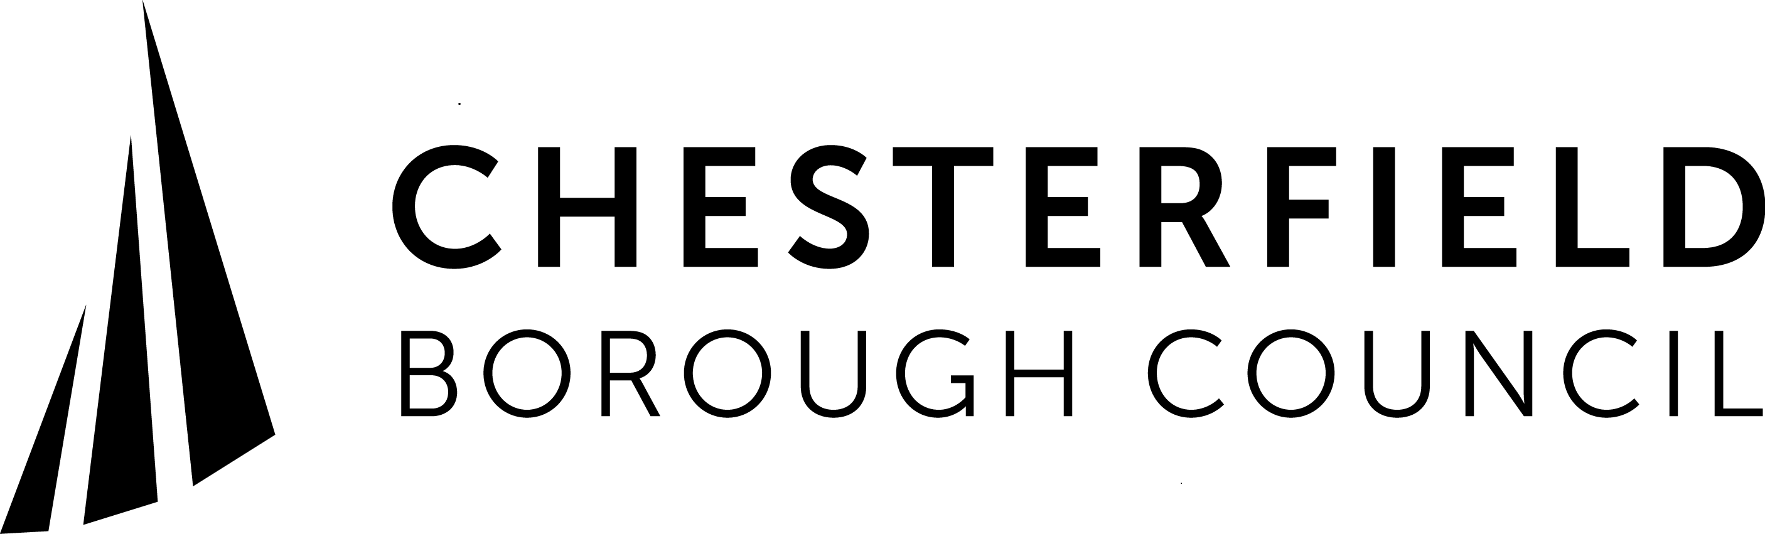
Refund Direct into Bank Account
Details of bank account to be credited:

Sort Code:
Account No:
Account Name:
I / We authorise the above bank account to be credited with the overpayment.
Signed: ........................................................
Signed: ........................................................
Signed: ........................................................

When completed please return this form to:
Town Hall, Rose Hill, Chesterfield S40 1LP
Or email to rentsrefunds@chesterfield.gov.uk

Town Hall, Rose Hill, Chesterfield S40 1LP
Chesterfield Borough Council is committed to protecting your privacy. We will process your personal data for the purpose of administering Council Tax. The Council may share your information with other public bodies/agencies where it has a statutory requirement, legal obligation to do so. This may include sharing information for crime and taxation purposes such as fraud prevention.
If you require more information regarding the processing of your personal information and details of the rights, you have under data protection law please go to
www.chesterfield.gov.uk/privacy or alternatively telephone the customer services team on 01246 345345.

