Chesterfield Borough Council
Rent Refund Claim Form
Property Address:
Rent Reference Number:
Name of Tenant(s):
Amount of Refund:

I declare that payment of Rent and other charges has been made by the Tenant(s) shown above and the estate of the tenant is tenant is entitled to a refund of the overpayment.

Signed………………………………………………………… Date.……………………….
(This claim form must be signed by the executor or administrator of the estate).

The refund will, under normal circumstances, be payable to:

EXECUTORS OF MRS A.EXAMPLE DECEASED

If a bank account has not been opened to deal with the assets and liabilities of the estate or the estate has been distributed and any bank account has now been closed, then it is possible to refund the personal representatives or executor or a nominated beneficiary of the estate. If this is the case, please complete the following section:

I am the executor*/personal representative* (delete as appropriate) of the above deceased and I state that a bank account has not been opened nor will one be opened, or if one was opened it has been closed, in respect of the estate and I wish the refund to be made payable to:

We will process your data for the purpose of administering a rent refund. If you require more information and details of the rights, you have please go to www.chesterfield.gov.uk/privacy.

Name: ..................................................................................................... (please print full name) Address: ........................................................................................................................................
and I hereby indemnify the Council against any claim or action made or brought in respect of the said refund.

Signed: .........................................................................................Date: ........................................

Please complete the following section:

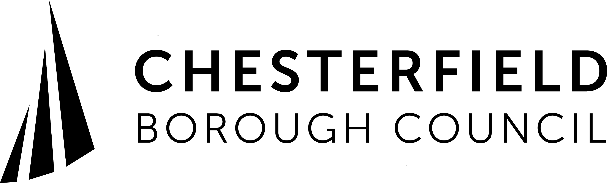
Refund Direct into Bank Account
Details of bank account to be credited:
Sort Code:
Account No:
Account Name:
I / We authorise the above bank account to be credited with the overpayment.
Signed: ........................................................
Signed: ........................................................
Signed: ........................................................

When completed please return this form to:

Town Hall, Rose Hill, Chesterfield S40 1LP
Or email to www.rentsrefunds@chesterfield.gov.uk

Chesterfield Borough Council is committed to protecting your privacy. We will process your personal data for the purpose of administering Council Tax. The Council may share your information with other public bodies/agencies where it has a statutory requirement, legal obligation to do so. This may include sharing information for crime and taxation purposes such as fraud prevention.
If you require more information regarding the processing of your personal information and details of the rights, you have under data protection law please go to
www.chesterfield.gov.uk/privacy or alternatively telephone the customer services team on 01246 345345.

