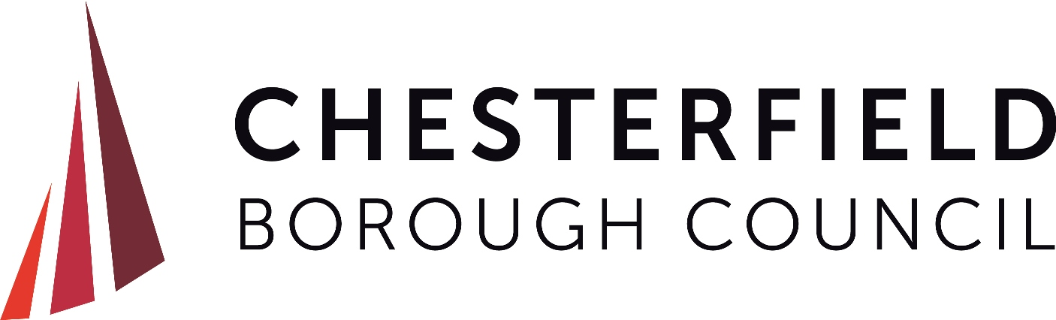

Refreshment Stands – Environmental Health Form

Event Venue: …………………………………………………………………..
Event Date: ……………………….

- Name of business: (unit/mobile etc.) __________________________________________
- Type of food / drink being served: ___________________________________________
- Registration number of unit/mobile: ____________________
- Name of food business Operator (FBO) Please print _____________________________
- Address of business: (where kept overnight) ____________________________________

__________________________________________________________________________

Which Local Authority is your business registered with?

Name of Local Authority:

Date of Registration

When did the Local Authority last inspect your business base/stall/vehicle?

Date

Food Hygiene Rating Score

Food and Health & Safety - Please ensure you have the following on site for

Inspection:

Tick the box to confirm

Safer Food Better Business or equivalent completed documentation
Training certificates
Gas inspection report (current).
Portable appliance test certificate (current)

Tick the box to confirm the following items will be adhered to

LPG gas canisters to be placed in a secure cage with adequate ventilation
Appropriate firefighting equipment to be available
Refuse bin(s) will be placed outside the unit

Are you a member of NCASS Yes/No – if Yes Number …………………………….

DECLARATION

I understand that Chesterfield Borough Council may approach any local authority mentioned above to verify the statements I have given.

Signed Date ______________

Print name __________________________________

Chesterfield Borough Council carries out spot checks and you may be inspected at the event. Failure to have the above items may lead to further action being taken on the day.
Please return completed form to food@chesterfield.gov.uk

